Customer Needs and Final Concepts

Team Members:
Alex Pérez Alarcon
Eric Bryniarski
Matthew Faller
Riley Keating
Sam Schulz
Katie Tooher
Jordan Vangarde

Advisor:
Nadiyah Johnson

Date: 11/11/2022

Table of Contents

1. Customer Profiles . . . . . . . . . . . . . . . . . . . . . . . . . . . . . . . . . . . . . . . . . . . . . . . . . . . . . . . . . . .2
2. Data Collection . . . . . . . . . . . . . . . . . . . . . . . . . . . . . . . . . . . . . . . . . . . . . . . . . . . . . . . . . . . . .2
3. Customer Statements and Interpreted Needs . . . . . . . . . . . . . . . . . . . . . . . . . . . . . . . . . . . . .4
4. Market Research . . . . . . . . . . . . . . . . . . . . . . . . . . . . . . . . . . . . . . . . . . . . . . . . . . . . . . . . . . .9
5. Test Table . . . . . . . . . . . . . . . . . . . . . . . . . . . . . . . . . . . . . . . . . . . . . . . . . . . . . . . . . . . . . . . .10
6. Needs Hierarchy . . . . . . . . . . . . . . . . . . . . . . . . . . . . . . . . . . . . . . . . . . . . . . . . . . . . . . . . . . 12
7. Metrics . . . . . . . . . . . . . . . . . . . . . . . . . . . . . . . . . . . . . . . . . . . . . . . . . . . . . . . . . . . . . . . . . . 13
8. Final Concepts . . . . . . . . . . . . . . . . . . . . . . . . . . . . . . . . . . . . . . . . . . . . . . . . . . . . . . . . . . . . 15

Customer Profiles
  - Milwaukee Community Members
    - These customers include Milwaukee community members who have an interest in learning about and interacting with Milwaukee’s black-owned businesses.
  - MKE Black Featured Business Owners
    - These are business owners who have their businesses featured on the application and want to keep in touch with comments or how many favorites their businesses are getting.
  - Other Business Owners
    - These might be business owners whose businesses are not featured on the application but will use the app to note other businesses. These customers might be using the application to determine if they want to submit an application to have their business featured on the mobile application or website.
  - Non-Local Consumers who support the vision of MKE Black
    - This type of user just wants to learn about what Milwaukee has to offer, and most likely supports the mission to empower and connect with black-owned businesses in the greater Milwaukee area.

Data Collection

Survey
    - To collect data that would assist with the conceptual outline for our mobile application, the two MKE Black teams worked together to create two google form surveys. The first survey was directed towards community members who would use the application, and the second survey was directed towards business owners who would be interested in having their business featured on the MKE Black website or mobile application.
    - Consumer Survey
This survey consisted of 14 questions intended to find the ideal experience for our end-users interacting with businesses. It yielded 41 responses used to interpret our needs hierarchy.
    - Business Survey
The business-oriented survey was meant to understand what business stakeholders desired from the app. It had 11 questions and yielded 5 incomplete responses. It did not yield sufficient responses to consider in our needs hierarchy for now.

Customer Statements and Interpreted Needs
Table 2: Interpretation of Customer Needs of 41 Responses

# | Questions | Interpreted Responses
 | Would you prefer to use the website or mobile app? (single response)
1 | ● Website: 22.2%  ● App: 29.2%  ● Both: 39%  ● Neither 9.8% | There is substantial interest in both the website and mobile app. Our project will need to produce well-developed products in both domains.
 | How would you like to interact with the businesses? If you have more specific interests, please type your answer in "Other". (multi response)
2 | ● Upvote/Like Button: 71.4%  ● Comment to Business: 68.6%  ● Favorites: 60%  ● Direct messages: 57.1% | Consumers would like to see an upvote button as a way to view the popularity of a certain business. Additionally, having the ability to leave comments for the businesses and sending direct messages may be important features.
 | What information would you like to see from the businesses featured on these applications? Examples: information and facts about a company, to products they have, contact info, etc.
3 | Products they offer a link to the website and proximity of the business to me | Consumers would like functionality that makes access to the business contact info more convenient.
4 | A map with locations, and a filter for type of location(i.e. food , fashion, service, etc.) | Consumers want the ability to see the location of businesses from a birds eye view. Consumers want to quickly be able to visually see how far they are from certain businesses and what routes they can take.
5 | Facts who their partners are their values | Consumers want an overview of the businesses and their values. Consumers care about the mission of these businesses when deciding where to give their support. Businesses should have the ability to display a bio on the app/website.
6 | Product information, facts about charities being ran by the company for a cause, reviews about the company’s products and new developments. | Consumers want to know what the business is offering and their mission overall. Consumers care about the small details when it comes to supporting local businesses. Understanding their focus, goals, and background is crucial for consumer decisions. Businesses should have the ability to display a bio on the app/website.
7 | Hours, menu/products, images | Consumers want to see what the business offers and visually see what products/services are being offered. App/website should support external links and files from businesses. Consider things like a virtual menu or business website.
 | Would you like to share businesses or info that you see from this technology on other social media? (for example, sharing it on Twitter or Facebook)
8 | SMS, Instagram, Twitter, Facebook, Share button,Tiktok, Whatsapp | The app/website should have the ability to share business links on a variety of common platforms.
 | What other features would you desire most from the app or website in order for you to use it?
9 | Black event meet ups | Some consumers may want to utilize the app/website as a hub for everything related to Black social/business life in Milwaukee. Consider businesses, meetups, and possibly other events.
10 | Tech support for the business, links to their media platforms, suggestion boxes | The app/website should display the contact information and social media handles or links for businesses. Additionally the app/website should give consumers the ability to send a message and/or leave a comment for businesses to review.
11 | Filtering by service and/or product | Consumers want to be able to identify what products/services are being offered by each business. Furthermore, the app should allow consumers to quickly filter the businesses by their product/service/location category.
12 | Color and voice feature | Consumers may like to see options to change theme color and to have an option to select a button to call a business.
13 | Pictures and where it is located | Consumers want to visually see what products/services are being offered by these businesses. Additionally, they want to know where the businesses are located throughout Milwaukee
14 | Search for keyword | Consumers want to easily find specific businesses or other business related info. App/website should have a search option.
15 | No ads | Consumers do not like to be spammed with unwanted ads. Possible options to avoid ads would be to have a paid for app/website account.???? ASK TEAM!!
Please rate how important the following options are for you to have the best experience with this technology. (1 - Not Important, 3 - Neutral, 5 - Very Important)

Interactivity: Having the ability to interact with other community members or business owners.
16 | Average: 3.36 | The majority of consumers would like to be able to interact with the community and with the businesses. The app/website should incorporate functionality for comments/likes/messaging.
Please rate how important the following options are for you to have the best experience with this technology. (1 - Not Important, 3 - Neutral, 5 - Very Important)

Accessibility: How easy it is to find what you are looking for within the application or website
17 | Average: 4.61 | Consumers want ease of use. The app/website should have functionality to search/save specific businesses.
Please rate how important the following options are for you to have the best experience with this technology. (1 - Not Important, 3 - Neutral, 5 - Very Important)

Accuracy: Keeping the content on the app and website up to date with current businesses.
18 | Average: 4.69 | Consumers expect to see up-to-date information. Business info should be stored in a way that can be updated often and easily.
Please rate how important the following options are for you to have the best experience with this technology. (1 - Not Important, 3 - Neutral, 5 - Very Important)

Diversity of Businesses: There are many different types of businesses featured on the app and website. (retail, restaurants, clothing, etc)
19 | Average: 3.88 | The majority of consumers would like to see a list of diverse business types in the app/website. The app/website should be capable of hosting many different types of businesses.
Please rate how important the following options are for you to have the best experience with this technology. (1 - Not Important, 3 - Neutral, 5 - Very Important)

Community Events: Different events that are being hosted across the city by local businesses are showcased on the website or app.

20 | Average: 3.86 | The majority of consumers would find it useful/preferred to find community events in the app/website. The app/website should have the ability to showcase local events.
 | What kind of communities/businesses would you like to see and connect with on the applications? (Like local owned retail, restaurants, service, etc)
21 | Black film communities | Consumers would like to see more niche businesses featured on the app/website.
 | Restaurants, clothing/fashion, Any communities or businesses, retail, small businesses and influences, non-profits, grocery, local own niche services, game places,broad business scope, local gifts, opportunities to volunteer | Consumers would like to see a broad range of different businesses on the app/website. App/website should be modular enough to host a broad range of businesses.
22 | clothing/fashion | Same as above.
23 | Auto services and book stores | Same as above.
 | If the app/website contained coupons or discounts for these locally owned businesses, would that incentivize you to use the app more?
24 | Yes 91.9%  No 8.1% | Consumers would like to see extra incentive to use the app. App/website should include support for coupons/discounts

Market Research (Similar Tech Research Section)
A few references to applications similar to our product:
https://www.blappapp.com/ : Blapp App, Finding black owned businesses
https://wbbtoo.com/ : We Buy Black, a marketplace for products made from black-owned businesses
https://web.mercadomke.com/en/list : Provide online directory and platform for MKE based Latino businesses.
https://www.eatokra.com/ : Online Ordering of Black-owned restaurants, has reviews for businesses.
https://post21shop.com/ : Post21 Online store of products such as home goods by black creators
Benchmarking against other Applications:
Feature | Competitor App | Our Product
Show nearby black businesses in IOS and android app | Blapp(Mobile): a database that resembles Google Maps, you can use the same app to find businesses in many cities. | Our tech leverages local pride and organizations to make an unrivaled network of businesses on a web or mobile application.
Selling products made by Black creators through an online marketplace. | We buy Black (Website): Online marketplace for selling black-made products. | Our tech is a platform for community-oriented businesses to visit and order from. (Services and products)
A platform for businesses in Milwaukee to grow | Mercadomke (Website): Provides an online marketplace and platform for Latino businesses in MKE. | Our technology interacts with businesses in different ways (favorite/ newsletters /order /discover) with a user profile.
Ordering and discovering Black-owned restaurants | EatOkra (Website/Mobile): Directory of unclaimed restaurants to rate and explore. Provides API usage to order online. (Doordash, Uber, etc.) | Our tech aims to interact with verified and bespoke business directories with various similar features.
Online marketplace for home goods products created by black creators | Post21 (Website): Similar to We Buy Black, focuses on modern design. | Our tech interacts with local businesses as a platform to sell, discover, and stay in touch with the community.
Conclusion: Ultimately, our product differentiates itself by leveraging local organizations, businesses, and users to stimulate a networking platform with its selected stakeholders and new users.

Test Table
Test Table of Various Things To Test
Test | Description of Test | Passing Requirements | Pass/Fail
Software App Function | A pass/fail document will be created in order to verify whether certain features function properly. | The application works with minimal bugs and functions as designed. | TBD
Database Function | A pass/fail document will be created in order to verify whether certain features function properly. (Certain functions needed: secure storage of data, updating the data as needed) | The database works with no bugs and functions as designed. | TBD
Compatibility with iOS and Android | Determine if the mobile device is able to install and use the app. | Not all phones need to comply. The app must be able to be downloaded and used successfully on 90% of current iOS and Android phones. | TBD
Skill Required to Navigate App | Have users download and use the app. Administer a survey on the users of the app’s ease of use. | In the survey, on a scale of 1 - 5, the average must be at least 3.5.  (Where 1 = not easy to use, 5 = easy to use.) | TBD
Skill Required as Admin | Administer a survey on admins managing the app (who may not be COSC-based) on how easy it is to navigate admin menus and update information as needed. | In the survey, on a scale of 1 - 5, the average must be at least a 4.0 in ease of use.  (Where 1 = not easy, 5 = very easy/intuitive.) | TBD
Modularity | Input in a few test businesses of various types into the database. Check via the app what info it displays and how it displays it. | The app has to be able to properly display the appropriate UI and accompanying information for any business type at least 90% of the time. | TBD
Maintaining Updated & Accurate Business / Organization Information | Administer a survey on current users on how useful and accurate the users found the information posted about certain companies/businesses. (Usefulness and accuracy of info will be asked separately.) | In the survey, on a scale of 1 - 5, the average must be at least 3.5 in usefulness and 4.0 in accuracy.  (Where 1 = not useful, 5 = very useful for usefulness. For accuracy, 1 = not accurate, 5 = very accurate.) | TBD
Software Compatible with Future Software Updates | Rollback iOS and Android devices to previous versions, and then run the app. Also, update iOS and Android devices to their latest software version, then run the app on it. | The app must be compatible with future iOS and Android software updates. | TBD

Benchmarks and Test
Software Function
Cannot be verified at the moment, but upon development, a pass/fail test shall be administered.

Database Function
Cannot be verified at the moment, but upon development, a pass/fail test shall be administered.

Compatibility with iOS and Android
The app will be able to be installed and used on recent versions of iOS and Android phones.

Skill Required to Navigate App
The app will be easy to use for all users.

Skill Required as Admin
The related admin menus will be easy to use for the people reviewing business applications or updating info.

Modularity
The app must be modular enough such that the app can be used to host information on different business types and their different needs.

Maintaining Updated & Accurate Business / Organization Information
The information about other businesses/organizations will be kept up-to-date and accurate.

Software Compatible with Future Software Updates
The app will be developed in such a language/app that compatibility with both iOS and Android will be maintained.

Needs Hierarchy
Table 4: Interpretation of Customer Responses Weighted In Importance From Least (1) to Most (5)

# | Need | Importance
1 | Ease of Use/Accessibility  (User-friendly UI, Tools for special needs) | 5
2 | Up to Date Information  (Business details are updated frequently) | 4
3 | Accuracy  (Business details are correct) | 3
4 | Interconnectivity  (ability to function/connect with other app) | 3
5 | Intraconnectivity  (ability to interact/connect within app) | 3
6 | Modularity  (ability to host different business types) | 5
7 | Platform Compatibility  (usable on both Android and iOS) | 4
8 | Theme Customization  (ability to customize color/theme) | 1

Metrics
Table 5: Metrics Descriptions

Need Number | Metric | Importance | Units | Marginal Value | Ideal Value
1 | Skill Required for Operation | 5 | Technical Skill | Moderate | Beginner
7 | Android/IOS | 4 | Binary | No | Yes
2 | Database updates | 4 | Updates Per Month | Updated < Monthly | Updated > Monthly
6 | Framework compatibility for hosting different business types | 2 | % of Business types that can be hosted | 80% of Business types can be hosted | 100% business types can be hosted
4 | Compatibility with different applications | 2 | # of compatible apps | 0 | 5
3 | Business related Information | 3 | % Accuracy of business information | 95% Accurate | 100% Accurate
8 | Usage of different themes | 1 | % of users not using default themes | 50% of users using a not default theme | 90% of users not using a default them

Final Concepts

Initial Concepts

The initial concept of the mobile application technology discussed with the stakeholders BLK City Collective & MKE Black was: create a white-label technology that contains functionality of the existing MKE Black app, while adding new features as prioritized stretch goals. The stretch goals are defined by importance: favorite businesses for users and a total favorite count for each business page, a rating for each business, and any additional API support (Google Table, Uber, Doordash, etc) that the stakeholders deem necessary. The technology must have a self-hosted directory that is shared with a web application. It must also have a submission form for review and approval.

Final Concepts

The surveys solidified the input stakeholders have shared, and their vision for the application did not change much. Our end-users would like intuitive ease of use and consistent user/business profile information. This means saving favorite locations and keeping up to date with the latest business updates of those locations. Ultimately, our minimum viable product is to create white-label mobile technology replicating the functionality of the MKE Black app with a self-hosted directory (meaning all the information about a business is viewable from within the app) and submission forms. The survey clarified the stretch goals are important and is what the end user desires other than the MVP. Our final concept does not change much thankfully due to the insight available from the iteration of the current MKE Black app.

Application Flowchart
    - The mobile application will be built with similar tabs and functions to the current mobile application with additional functionality. Things that remain the same are the different tabs that are seen on the homepage of the current application. The new functionality includes the customer profiles and log in ability, the ability to create favorites, the ability to share on social media, the ability to message or contact businesses directly with feedback, the ability to comment on business pages and the ability to have a favorites list. Additionally, the app will have an admin login since the stakeholders wanted a page to manage the businesses or look at applications from new businesses.
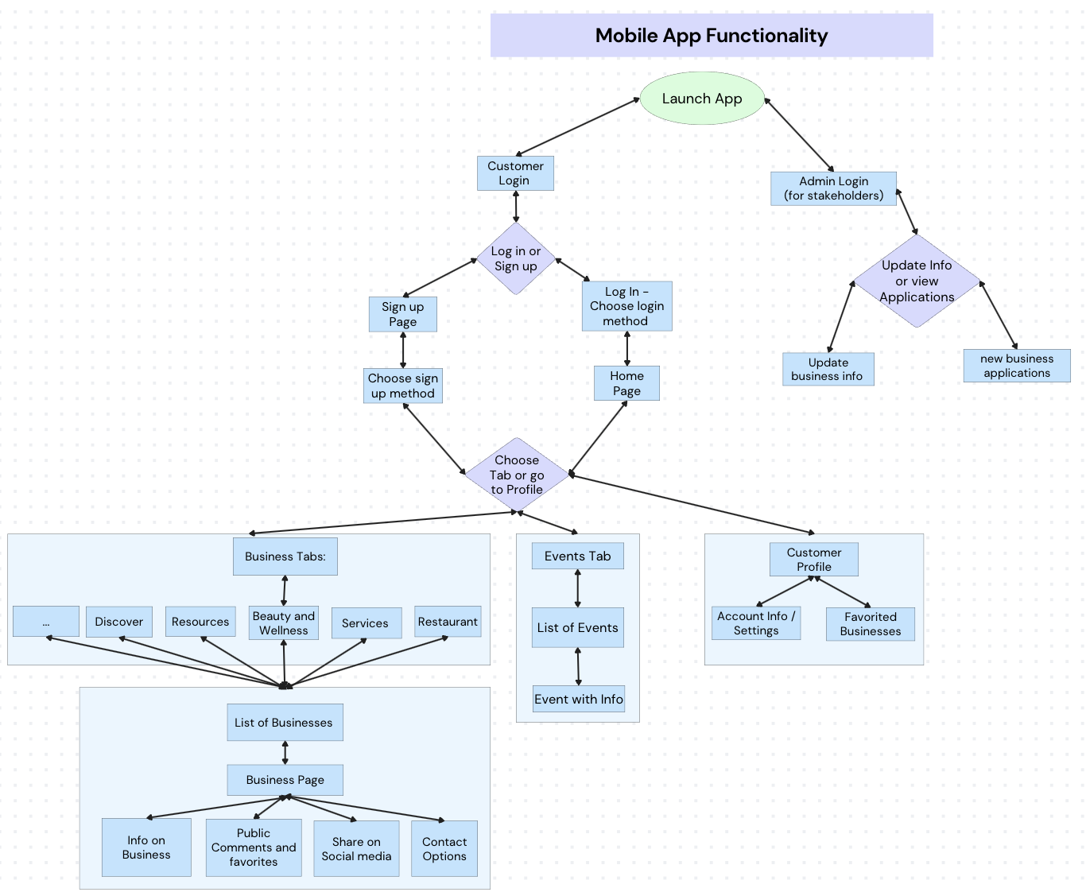

Database Flowchart
    - The database flowchart below describes a basic overview for the database architecture and setup. Both the website and the mobile app will be connected to one Google Firebase Realtime Database. Within the Firebase Realtime database, the data will have a few sections: Customer Data, Admin Data, and Business Data. The Customer Data section will have Authentication information (login info) as well as a favorites list per user. The admin data will have authentication info for each admin user and data for submitted applications. The business data will contain info about the businesses, such as about info to be displayed, images, etc. On the other hand Google Firebase Realtime databases also have an area to define database rules. These rules encompass security features as well as defining user authentication.
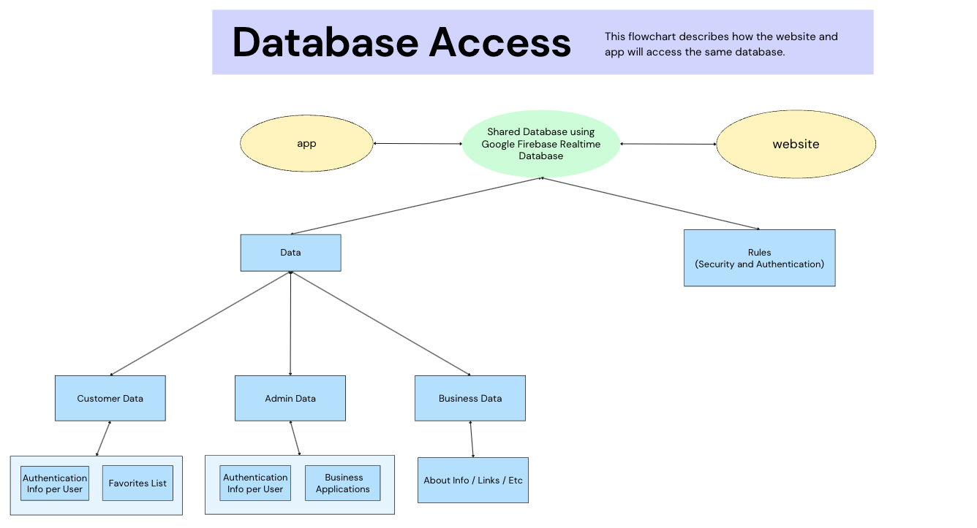

Figma Wireframe Designs
  - Login page
    - The logo is front and center, as it is the “cover” of the app that sets the color scheme.
    - Email/username and password entry fields, along with “Forgot password” and “Log in”, are the first buttons to appear—offer a positive experience for the end user who might often update the app or get logged out for other reasons.
      - Envelope/lock icons for email/password, respectively—visual indicators are important!
    - “Create an account” is next—big, inviting that a new user can’t miss.
      - The “or” between the login and account creation sections is important—without it, one might think to enter their information in the login email/password entry fields believing that they are in the process of creating their account, only to be met with more entry fiends after clicking “Create an account”. The “or” makes this separation clear.
    - Don’t care about liking and reviewing? “Continue as guest” is an option, which is great for out-of-towners who simply want to grab a quick bite to eat.
      - It’s the third option because it’s not ideal—we want to create frequent users. It’s not difficult to spot, however—we don’t want to prevent new users from finding the business they seek.
  - Business tab
    - The header introduces the user and creates a personalized user experience.
    - This concept lists 6 tabs that are already featured on MKE Black, with the potential to add more in the future.
    - Search bar up top ideally will allow the user to search both specific names, types, and keywords.
    - Settings/more page (the “…”) option will be visible on every page.
    - Can switch between businesses and events via a bottom slider.
  - List of businesses
    - Businesses can be filtered/sorted using the icon in the top left either alphabetically / by distance, or by specific items (like menu items for restaurants).
    - The businesses appear in an evenly-spaced list with a name and a quick visual—clicking on a specific business allows the user to see the address, hours, and description.
